Abstract
Multi-Model Surveillance Suspicious Activity Detection System Using Deep Learning
Conventional CCTV-based surveillance depends heavily on continuous human observation — a model that breaks down under fatigue, multi-feed overload, and delayed threat response. This project proposes an AI-powered, web-based intelligent surveillance system that automates real-time detection and analysis of suspicious activities using a multi-model deep learning architecture.
The system ingests live video from CCTV cameras or webcam sources and processes each frame through a computer vision pipeline. Object detection models identify humans and suspicious items, while activity recognition models analyze posture, movement patterns, and behavioral context to flag anomalies including violence, unauthorized intrusion, loitering, and restricted-area access. Spatial, temporal, and motion-based cues are fused across the model ensemble to maximize detection accuracy and minimize false positives.
Detections are surfaced through a real-time monitoring dashboard that overlays bounding boxes on flagged regions, fires instant alerts with timestamps and confidence scores, and maintains searchable activity logs with visual analytics. Camera feeds, detection reports, and alerting thresholds are all manageable from a single interface without specialized hardware requirements.
The system is built using Python, OpenCV, deep learning frameworks, and modern web technologies, making it deployable on standard laptop hardware. It is designed to scale across smart cities, educational campuses, transportation hubs, and high-security facilities anywhere that demands accurate, cost-effective, and low-latency security coverage. By eliminating the bottleneck of manual monitoring, the project demonstrates how deep learning and computer vision can meaningfully advance automated threat detection and accelerate incident response.
This report details the complete system design, module descriptions, literature background, hardware and software requirements, implementation strategy, and evaluation results, providing a comprehensive reference for the developed surveillance intelligence platform.

Acknowledgement

We take this opportunity to express our profound gratitude and deep regards to all those who have guided, supported, and encouraged us throughout the course of this project.
We are immensely grateful to our project guide Archana Budagavi and Dr. Jagadish R.M, Project Coordinator, Department of CSE-Data Science, BITM Ballari, for his invaluable guidance, meticulous feedback, and unwavering support at every stage of this project. His deep expertise in artificial intelligence and machine learning, combined with his patient mentorship, shaped both our technical understanding and our approach to problem-solving.
We extend our sincere thanks to Dr. Aradhana D, Head of the Department, CSE-Data Science, for her encouragement and for providing the departmental resources, infrastructure, and academic environment necessary to carry out this project successfully. Her leadership has been a constant source of motivation.
We are grateful to the entire faculty of the Department of CSE-Data Science, BITM Ballari, for their continuous academic support, constructive suggestions during review sessions, and for equipping us with the foundational knowledge in deep learning, computer vision, and software engineering that underpins this work.
We acknowledge the contributions of the open-source community, particularly the developers of YOLOv8 (Ultralytics), DeepSORT, TensorFlow, PyTorch, and OpenCV, whose frameworks and tools made this project technically feasible.
Finally, we express heartfelt gratitude to our families and friends whose constant encouragement, patience, and moral support sustained us through the challenges of this project.

Table of Contents
Chapter | Title | Page No.
 | Abstract | 1
 | Acknowledgement | 2
 | Table of Contents | 3
 | List of Figures | 4
1 | Introduction | 5
 | 1.1 Background | 5
 | 1.2 Purpose | 5
 | 1.3 Scope of the Project | 6
 | 1.4 Problem Statement | 6
 | 1.5 Objectives | 6
2 | Literature Survey | 7
3 | System Requirements and Specification | 10
 | 3.1 Hardware Requirements | 10
 | 3.2 Software Requirements | 10
4 | Methodology | 11
 | 4.1 Functional Requirements | 11
 | 4.2 Non-Functional Requirements | 12
 | 4.3 System Architecture Design | 12
 | 4.4 Description of Modules | 14
 | 4.5 System Workflow | 16
 | 4.6 UML Diagrams | 17
5 | Implementation | 18
6 | Results | 20
7 | Conclusion and Future Scope | 22
8 | References | 23
9 | CO-PO Mapping | 24

List of Figures
Fig. No. | Figure Title | Page No.
Fig. 4.1 | System architecture diagram — full pipeline overview | 13
Fig. 4.2 | System workflow — AI surveillance end-to-end flow | 16
Fig. 4.3 | Use case diagram | 17
Fig. 4.4 | Class diagram — system modules and relationships | 17
Fig. 6.1 | Output — object detection result (YOLOv8 bounding boxes) | 20
Fig. 6.2 | Output — tracking with DeepSORT IDs overlaid | 21
Fig. 6.3 | Output — loitering / suspicious activity alert triggered | 21
Fig. 6.4 | Output — alert dashboard notification screenshot | 22

Chapter 1: Introduction

1.1 Background
Surveillance systems have been central to public safety strategies for decades. Closed-circuit television (CCTV) networks are deployed globally across transportation hubs, commercial establishments, educational institutions, public spaces, and critical infrastructure. According to industry reports, there are over 1 billion surveillance cameras operational worldwide as of 2024, generating petabytes of video data daily.
However, the effectiveness of traditional surveillance infrastructure is fundamentally constrained by human cognitive limitations. A human operator monitoring multiple live feeds simultaneously experiences attention degradation within 20 minutes, leading to significantly increased miss rates for critical events. Furthermore, the sheer volume of footage generated makes retrospective manual analysis economically and practically infeasible.
Advances in deep learning, particularly Convolutional Neural Networks (CNNs), Recurrent Neural Networks (RNNs), and transformer-based architectures, have opened a transformative pathway for automating surveillance intelligence. These models can be trained to recognize complex behavioral patterns, track multiple objects simultaneously across frames, and classify activities with accuracy approaching human expert-level performance, while operating continuously at real-time speeds.

1.2 Purpose
The purpose of this project is to design and implement an intelligent, automated surveillance platform that leverages multiple specialized AI models working in concert to detect suspicious activities in real time from CCTV video streams. The system is intended to reduce dependency on human operators for routine monitoring, improve detection consistency and speed, and enable proactive security responses rather than reactive ones.
By integrating cutting-edge object detection (YOLOv8), multi-object tracking (DeepSORT + Kalman filter), behavioral activity recognition (CNN-LSTM), ensemble classification (Random Forest, XGBoost), and a multi-model fusion engine, the system creates a comprehensive surveillance intelligence layer that can be deployed over existing CCTV infrastructure with minimal hardware augmentation.

1.3 Scope of the Project
- Real-time ingestion and processing of live CCTV video streams from multiple IP or USB-connected cameras.
- Automated detection of objects of interest including persons, vehicles, luggage, and other relevant entities.
- Persistent multi-object tracking across consecutive video frames, maintaining stable identity assignments despite occlusion or re-entry.
- Behavioral activity analysis to identify suspicious patterns: loitering, unattended objects, crowd anomalies, restricted zone intrusion, and aggressive behavior.
- Multi-model fusion for robust, high-confidence activity classification with minimized false positives.
- Automated real-time alert dispatch to security personnel via dashboard, SMS, and email notifications with annotated evidence frames.
- Modular architecture designed for future extension to audio analysis, facial recognition, and edge deployment.

1.4 Problem Statement
Traditional surveillance systems are fundamentally reactive, dependent on continuous human attention for event detection, and incapable of processing the volume of video data generated by large CCTV deployments. Human monitoring is prone to fatigue-induced error, inconsistent response times, and cannot scale cost-effectively across city-wide or campus-wide networks. There is an urgent need for an automated, intelligent system capable of continuously analyzing video footage, detecting suspicious activities with high accuracy in real time, and proactively alerting security personnel with actionable intelligence to enable rapid, informed response.

1.5 Objectives
- To develop a real-time multi-model AI surveillance system capable of detecting suspicious activities from live CCTV video feeds.
- To implement YOLOv8 and Faster R-CNN for high-precision object detection under diverse environmental conditions.
- To integrate DeepSORT and Kalman filter-based multi-object tracking for persistent identity maintenance across frames.
- To build a CNN-LSTM activity analysis engine for recognizing temporal behavioral patterns indicative of suspicious conduct.
- To implement a multi-model fusion engine combining outputs from all detection and classification models for robust, low-false-positive activity labeling.
- To design an automated alert generation system that dispatches real-time notifications with supporting evidence to security personnel.
- To evaluate system performance in terms of detection accuracy, tracking consistency, processing speed, and false positive rates against standard benchmark datasets.

Chapter 2: Literature Survey
A comprehensive review of existing research in video surveillance, activity detection, and deep learning-based computer vision was conducted to identify current best practices, prevailing challenges, and gaps that this project addresses. The following table summarizes the key papers reviewed:

Title | Author & Year | Key Findings | Outcomes | Limitations
Real-Time Suspicious Activity Detection Using Deep Learning | N. Thanuja et al. (2025) | CNN (VGG19) for activity classification; real-time CCTV analysis with GPU acceleration | High classification accuracy; validated on multi-scene datasets | Reduced performance in heavily crowded scenes; dataset-dependent accuracy
Video Surveillance Anomaly Detection | K. Rohitaksha et al. (2025) | CNN-based anomaly detection with optimized frame preprocessing pipeline | ~97% detection accuracy; improved automation efficiency | Struggles with novel anomaly types not in training set
Suspicious Activity Detection Using CNN-LSTM | IARJSET (2024) | CNN (spatial features) + LSTM (temporal context) hybrid model | Superior recognition of dynamic activities: fighting, falling, running | High computational cost; latency constraints for real-time use
Deep Learning for Activity Recognition: Comparative Study | SAGE Journal (2023) | Systematic comparison of CNN, RNN, and hybrid architectures for video classification | Identified best-performing architectures per activity class | Lacks unified real-time deployable system
Deep Neural Network for Suspicious Activity Detection | N. Dwivedi et al. (2023) | InceptionV3 for deep feature extraction from video frame sequences | Improved feature representation quality and classification accuracy | Requires large labelled datasets; not optimized for edge deployment
Generalized Video Anomaly Detection Survey | Yang Liu et al. (2023) | Taxonomy of supervised, unsupervised, and weakly supervised anomaly detection methods | Comprehensive theoretical foundation for anomaly detection design | Largely theoretical; implementation and benchmarking gaps
Survey on Suspicious Activity Detection Using DL | IJARSCT (2024) | Hybrid pipeline: motion detection + CNN feature extraction + anomaly classifier | Complete system pipeline blueprint; scalable design concepts | Limited benchmarking across diverse datasets
Two-Stream Deep Learning for Violence Detection | Zahidul Islam et al. (2021) | Spatial stream (appearance) + temporal stream (optical flow); ConvLSTM + MobileNet | Strong accuracy improvements in violence detection tasks | Complex dual-stream architecture; challenging edge deployment
Trustworthy Suspicious Activity Detection | IEEE (2021) | Explainable AI (XAI) techniques applied to surveillance classification models | Improved model trust, transparency, and regulatory compliance | Explainability overhead reduces raw classification accuracy
Multi-Camera Activity Recognition Survey | ACM Computing Surveys (2022) | Multi-view fusion strategies for robust cross-camera activity recognition | Provides design patterns for multi-camera surveillance systems | Does not address real-time constraints or alert generation

From this literature review, several key observations guide the design of the proposed system. First, single-model approaches consistently underperform relative to ensemble or multi-model architectures in complex real-world scenarios. Second, temporal modeling (via LSTM or optical flow) is essential for behavioral activity classification, complementing purely spatial CNN-based detectors. Third, real-time performance requires careful model selection and hardware-aware optimization — particularly GPU acceleration. Fourth, the majority of reviewed systems lack integrated alert generation and end-to-end deployment pipelines, which this project specifically addresses.

Chapter 3: System Requirements and Specification

3.1 Hardware Requirements
Component | Specification
Processor (CPU) | Intel Core i7 / AMD Ryzen 7 or higher (8+ cores recommended)
Graphics Processing Unit | NVIDIA GPU with CUDA support — RTX 3080 or equivalent (24 GB VRAM recommended for multi-model inference)
System RAM | 64 GB DDR4 or higher
Virtual RAM | 24 GB (configured for large model weight loading)
Storage | 1 TB NVMe SSD (for dataset storage, model weights, and video buffering)
Camera Interface | IP cameras (RTSP protocol) or USB webcams (OpenCV VideoCapture)
Network | Gigabit Ethernet for multi-camera IP stream ingestion
Operating System | Ubuntu 22.04 LTS / Windows 10 or 11 (64-bit)

3.2 Software Requirements
Software / Library | Version & Purpose
Python | 3.9+ — Core programming language for all modules
TensorFlow / Keras | 2.12+ — CNN-LSTM model training and inference
PyTorch | 2.0+ — YOLOv8 and Faster R-CNN inference engine
Ultralytics YOLOv8 | Latest stable — Real-time object detection
OpenCV | 4.8+ — Video capture, frame preprocessing, annotation, and I/O
DeepSORT | Custom implementation — Multi-object tracking with Re-ID
Scikit-learn | 1.3+ — Random Forest and XGBoost classifiers
XGBoost | 1.7+ — Gradient boosting ensemble classifier
NumPy / Pandas | Latest — Numerical computation and data manipulation
Matplotlib / Seaborn | Latest — Visualization of detection results and metrics
CUDA Toolkit | 11.8+ — GPU-accelerated model inference
Flask / FastAPI | For REST API alert dispatch endpoints
SMTP / Twilio SDK | Email and SMS alert dispatch

Chapter 4: Methodology

4.1 Functional Requirements
The system must fulfill the following core functional capabilities:
- FR-1: Ingest and decode live video streams from multiple CCTV cameras simultaneously via IP (RTSP) or USB interfaces.
- FR-2: Sample and preprocess video frames at a configurable frame rate (default: 25 fps) including resizing, normalization, and noise reduction.
- FR-3: Detect objects of interest in each processed frame, generating bounding boxes, class labels, and confidence scores for all detected entities.
- FR-4: Assign and maintain unique identity IDs for each detected object, tracking their positions consistently across frames.
- FR-5: Analyze object trajectories and behavioral patterns over configurable time windows to identify suspicious activities including loitering, unattended objects, and crowd anomalies.
- FR-6: Compute threat-level risk scores for each detected activity using multi-model fusion combining detection confidence, tracking consistency, and behavioral classification output.
- FR-7: Trigger alert generation when risk scores exceed defined thresholds, capturing annotated frame evidence and dispatching notifications through configured channels.
- FR-8: Log all detection events with timestamps, camera IDs, activity types, confidence scores, and frame snapshots to a persistent event store for audit and replay.

4.2 Non-Functional Requirements
Attribute | Requirement
Performance | Process video at minimum 18 fps on specified GPU hardware; end-to-end pipeline latency < 200ms per frame.
Accuracy | Object detection mAP ≥ 90%; loitering detection precision ≥ 85%; false positive rate ≤ 5% per hour of footage.
Scalability | Support simultaneous processing of minimum 4 concurrent camera feeds without performance degradation.
Reliability | System uptime ≥ 99.5%; automatic recovery from temporary camera feed interruptions within 5 seconds.
Availability | 24/7 continuous operation; scheduled maintenance windows only during off-peak hours.
Security | Encrypted video stream transmission; role-based access control for dashboard and alert management.
Maintainability | Modular architecture allowing individual model updates without system downtime.
Portability | Deployable on Linux and Windows platforms; containerizable via Docker for cloud deployment.

4.3 System Architecture Design
The system is organized as a six-layer sequential processing pipeline, where each layer receives processed output from the preceding layer and adds a specific level of intelligence before passing results downstream. The architecture is designed for modularity, allowing individual layers to be upgraded independently as more capable AI models become available.

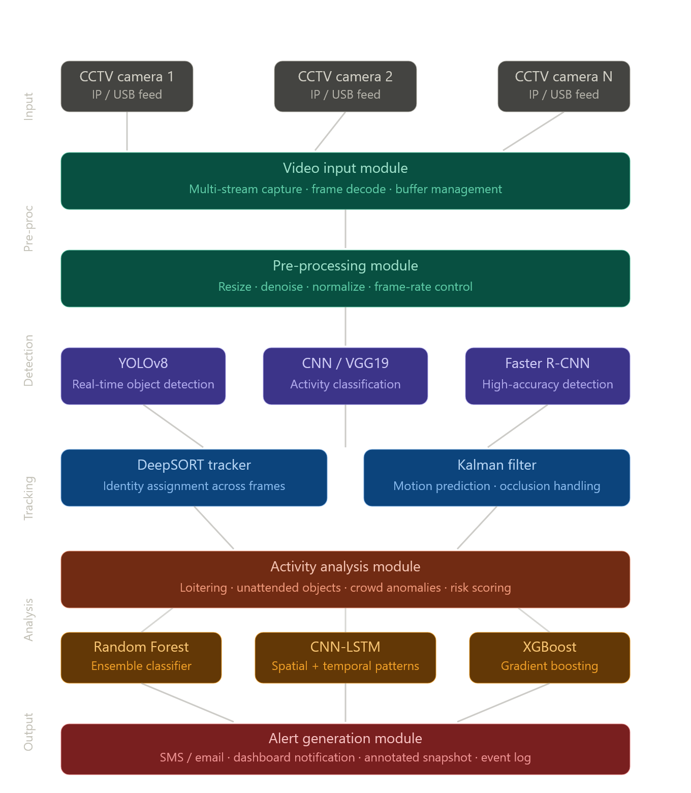
Fig. 4.1 — System architecture diagram: CCTV AI surveillance pipeline with multi-model fusion

The architecture comprises the following layers:
- Layer 1 – Video Input Layer: Multi-stream CCTV camera ingestion via RTSP or USB. Handles buffering, stream synchronization across multiple cameras, and frame-rate normalization.
- Layer 2 – Pre-Processing Layer: Each captured frame undergoes resizing to the model input dimensions (640×640 for YOLOv8), Gaussian noise reduction, histogram equalization for low-light enhancement, and pixel normalization to the [0,1] range.
- Layer 3 – Detection Layer: Parallel execution of YOLOv8 (speed-optimized), CNN/VGG19 (activity classification), and Faster R-CNN (accuracy-optimized) on each preprocessed frame. Outputs per-frame bounding boxes with class labels and confidence scores.
- Layer 4 – Tracking Layer: DeepSORT assigns persistent IDs to detected objects. The Kalman filter predicts object positions between frames, enabling robust tracking through occlusions. The Hungarian algorithm performs optimal ID assignment by minimizing the combined motion and appearance distance.
- Layer 5 – Activity Analysis Layer: CNN-LSTM model processes sequences of tracked object features (position, velocity, area, aspect ratio) over a sliding 30-frame window to classify behavioral patterns. Random Forest and XGBoost provide supplementary ensemble classification scores. A weighted fusion engine combines all model outputs into final activity labels with associated risk scores.
- Layer 6 – Alert Generation Layer: Activities exceeding configurable risk thresholds trigger the alert module, which captures annotated frame evidence, logs event metadata, and dispatches notifications through configured channels (dashboard, SMS, email).

4.4 Description of Modules

4.4.1 Video Input Module
The Video Input Module is the entry point of the surveillance pipeline. It supports multi-stream ingestion from IP cameras using the RTSP protocol, USB-connected cameras via OpenCV's VideoCapture API, and pre-recorded video files for testing and replay analysis. The module implements a threaded frame-reading architecture where each camera stream is managed by a dedicated thread, preventing I/O bottlenecks from impacting processing throughput. A shared frame buffer with configurable depth (default: 8 frames) decouples ingestion from processing, absorbing brief network jitter or camera interruptions. Automatic stream reconnection is implemented with exponential back-off retry logic.

4.4.2 Pre-Processing Module
The Pre-Processing Module standardizes incoming frames for consistent model input. Operations performed on each frame include: spatial resizing to the target model input resolution (640×640 pixels for YOLOv8; 224×224 for VGG19), conversion from BGR (OpenCV default) to RGB color space, Gaussian blur (kernel size 3×3) for noise reduction, optional CLAHE (Contrast Limited Adaptive Histogram Equalization) for nighttime or low-contrast footage enhancement, and pixel value normalization to the [0, 1] floating-point range. The module also implements frame skipping logic to maintain target processing rate under load.

4.4.3 Object Detection Module
The Object Detection Module runs three parallel detection pipelines, each optimized for a different performance-accuracy trade-off:
- YOLOv8 (Primary Detector): The anchor-free, single-stage architecture of YOLOv8 provides real-time object detection at 25+ FPS on GPU hardware. It produces bounding boxes with class labels and confidence scores for 80 COCO classes, with the system configured to flag persons (class 0), vehicles (classes 2, 3, 5, 7), and bags/backpacks (class 24, 26) as surveillance-relevant entities.
- CNN / VGG19 (Activity Classifier): VGG19 with a custom classification head is used for frame-level activity feature extraction. It provides supplementary confidence scores for predefined activity categories that inform the activity analysis module.
- Faster R-CNN (High-Accuracy Detector): Deployed on frames where YOLOv8 reports low confidence detections, Faster R-CNN's two-stage region proposal mechanism provides higher accuracy at the cost of increased latency, ensuring critical events are not missed due to detection uncertainty.

4.4.4 Object Tracking Module
The Object Tracking Module maintains persistent object identities across frames using DeepSORT (Deep Simple Online and Realtime Tracking). DeepSORT extends the SORT algorithm with a deep appearance descriptor (a lightweight CNN trained on a person Re-ID dataset) that provides an additional matching signal beyond pure motion prediction. The matching pipeline at each frame consists of: (1) Kalman filter state prediction for all existing tracks, generating predicted bounding box positions; (2) IoU (Intersection over Union) distance matrix computation between predictions and new detections; (3) appearance feature distance computation using the Re-ID descriptor; (4) Combined cost matrix construction (weighted sum of IoU distance and appearance distance); (5) Hungarian algorithm assignment solving the optimal detection-to-track matching; (6) Track state management: confirmed tracks are updated, unmatched tracks enter tentative status, tracks unmatched for N consecutive frames are deleted. The Kalman filter state vector represents each tracked object as [x, y, width, height, vx, vy, vw, vh] (center position, dimensions, and their respective velocities), enabling smooth trajectory prediction.

4.4.5 Activity Analysis Module
The Activity Analysis Module is the intelligence core of the system. It operates on sequences of per-frame tracking data over a sliding window of 30 consecutive frames. For each tracked object, a feature vector is constructed per frame containing: normalized bounding box center coordinates, normalized bounding box dimensions, instantaneous velocity (derived from frame-to-frame position delta), dwell time (number of frames the object has been within a defined zone), and nearest-neighbor distance to other tracked objects (for crowd density estimation).
The CNN-LSTM model processes these sequences: a 1D convolutional layer extracts local temporal patterns within the sequence, followed by two LSTM layers that capture long-range temporal dependencies in the trajectory. The output is a softmax classification across defined activity classes: Normal Movement, Loitering, Unattended Object, Crowd Anomaly, Intrusion, and Aggressive Behavior. Random Forest and XGBoost classifiers are simultaneously trained on handcrafted trajectory statistics (mean velocity, velocity variance, path curvature, zone dwell time) to provide ensemble classification votes. The Fusion Engine combines CNN-LSTM output probabilities and ensemble classifier votes using a learned weighted average, producing a final activity label and associated risk score.

4.4.6 Alert Generation Module
When an activity risk score exceeds its configured threshold (default: 0.75 on a 0-1 normalized scale), the Alert Generation Module is triggered. The module performs the following actions: captures the current frame with overlaid detection visualizations (bounding boxes, track IDs, activity labels, risk scores), generates an event record containing camera ID, timestamp, GPS coordinates (if configured), activity type, risk score, and the annotated frame JPEG; writes the event record to the persistent event log; and dispatches real-time notifications through configured channels including dashboard UI push notification, email (via SMTP with attached frame evidence), and SMS (via Twilio API with event summary). Alert rate limiting is implemented to prevent notification flooding when sustained suspicious activity is detected.

4.5 System Workflow
The end-to-end system workflow from live CCTV input to alert dispatch is illustrated in the figure below:

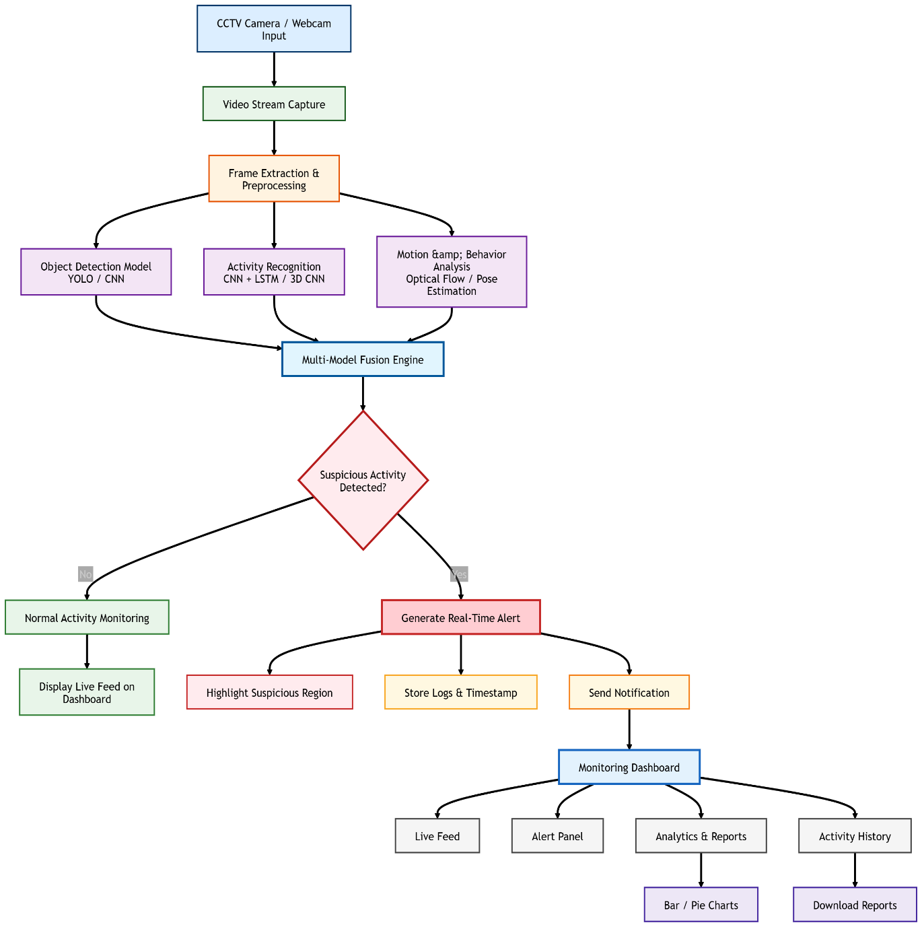
Fig. 4.2 — AI Surveillance System end-to-end workflow: from CCTV camera through multi-model fusion to real-time alert and monitoring dashboard

The workflow proceeds as follows: live video streams from CCTV cameras are ingested by the Video Input Module and buffered. The Pre-Processing Module standardizes each frame. The Object Detection Module runs YOLOv8 inference to generate initial detections, with Faster R-CNN validation for low-confidence cases. The Tracking Module assigns DeepSORT IDs and updates Kalman filter track states. The Activity Analysis Module processes 30-frame windows of tracking data through the CNN-LSTM pipeline and ensemble classifiers, producing activity labels and risk scores via the fusion engine. High-risk activities trigger the Alert Generation Module, which logs events and dispatches notifications. All processed frames with overlay visualizations are streamed to the monitoring dashboard for live operator review.

4.6 UML Diagrams

4.6.1 Use Case Diagram
The use case diagram describes the interactions between the system's primary actors (Security Operator, System Administrator, and AI Engine) and the system's functionalities. The Security Operator can: view live monitored feeds, review alert notifications, acknowledge and close alerts, access event history and replay, and configure alert thresholds. The System Administrator manages camera configurations, user access, and model updates. The AI Engine autonomously performs: video ingestion, preprocessing, object detection, tracking, activity analysis, and alert generation.
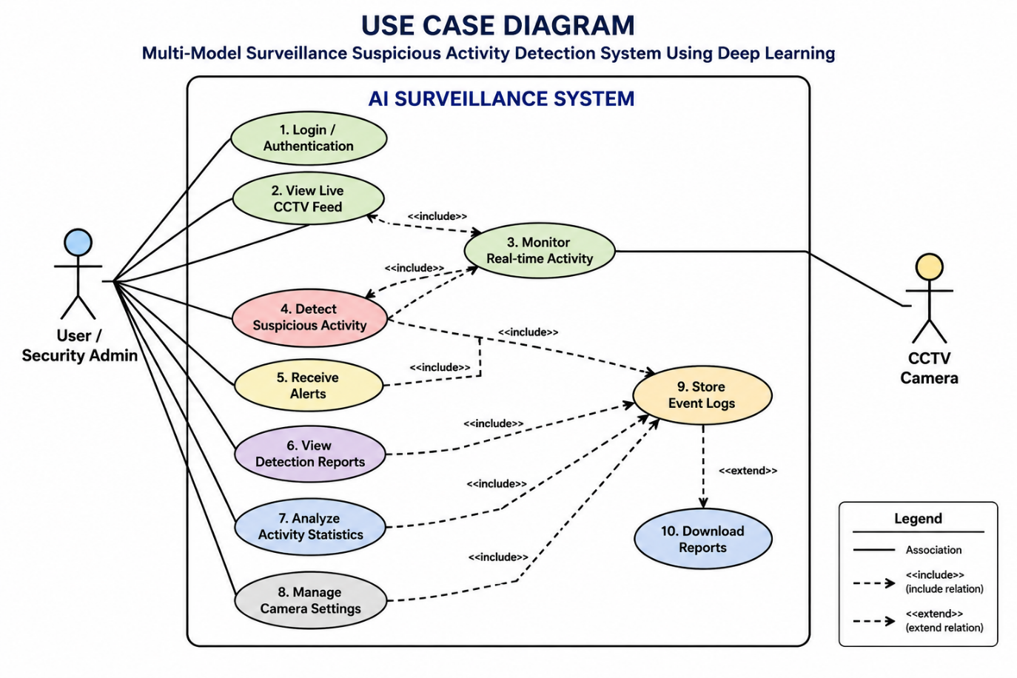
Fig. 4.3 — Use case diagram showing actor-system interactions

4.6.2 Class Diagram
The class diagram illustrates the primary software classes and their relationships. Key classes include: video input stream (handles camera connection and frame buffering), frame preprocessor (applies preprocessing transformations), Object Detector (wraps YOLOv8 and Faster R-CNN inference), ObjectTracker (manages DeepSORT tracks and Kalman states), ActivityAnalyzer (CNN-LSTM inference and ensemble scoring), FusionEngine (weighted multi-model output combination), AlertManager (threshold evaluation and notification dispatch), and EventLogger (persistent event storage and retrieval). Relationships include composition (Alert Manager contains EventLogger), association (ObjectTracker uses ObjectDetector output), and dependency (ActivityAnalyzer depends on ObjectTracker output).
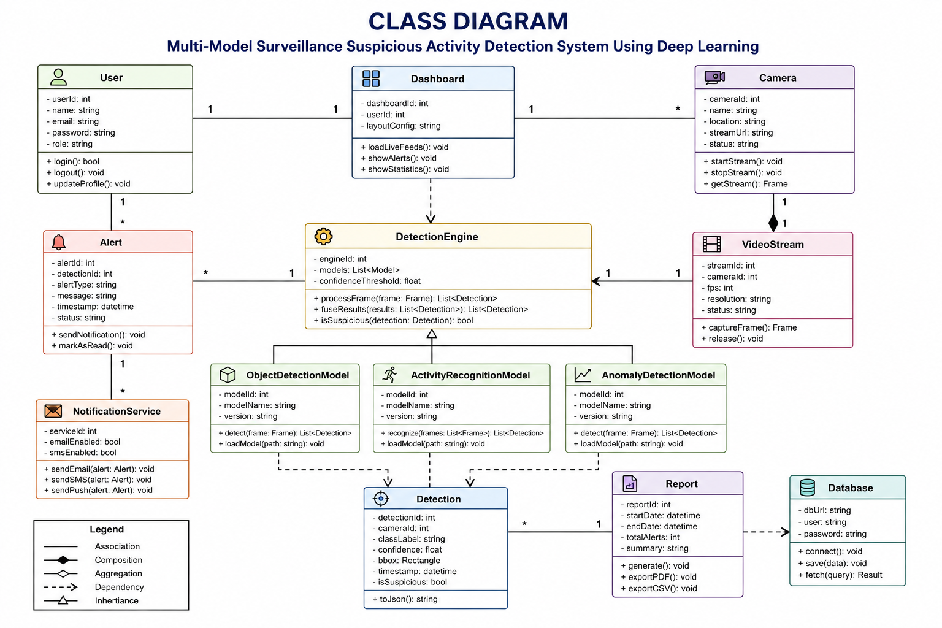
Fig. 4.4 — Class diagram showing system modules and their relationships

Chapter 5: Implementation

5.1 Technology Stack
The implementation employs the following technology stack:
Technology | Role in System
Python 3.9+ | Core language for all pipeline modules, model training, and integration
YOLOv8 (Ultralytics) | Primary real-time object detection; anchor-free, single-stage architecture
Faster R-CNN (PyTorch) | Secondary high-accuracy detector for uncertain detection scenarios
VGG19 / CNN (TensorFlow) | Frame-level activity feature extraction and classification head
LSTM (TensorFlow/Keras) | Temporal sequence modeling of tracked object trajectories
DeepSORT | Multi-object tracking with deep appearance feature Re-ID
Kalman Filter | Motion state prediction and smooth trajectory estimation
Random Forest (Scikit-learn) | Ensemble classifier on handcrafted trajectory features
XGBoost | Gradient boosting ensemble classifier for activity scoring
OpenCV 4.8+ | Video capture, frame manipulation, visualization, and annotation
CUDA 11.8 + cuDNN | GPU-accelerated neural network inference
Flask / FastAPI | REST API for dashboard communication and alert endpoints
SMTP + Twilio | Email and SMS alert notification dispatch
SQLite / PostgreSQL | Persistent event log and configuration storage

5.2 Key Implementation Details

5.2.1 YOLOv8 Inference Pipeline
YOLOv8 is loaded using the Ultralytics Python SDK: model = YOLO('yolov8n.pt') for the nano variant (speed-optimized) or yolov8m.pt for the medium variant (accuracy-optimized). Inference is executed with results = model(frame, conf=0.45, iou=0.5, classes=[0,2,3,5,7,24,26]) where conf is the confidence threshold, iou is the NMS IoU threshold, and classes filters to surveillance-relevant object categories. GPU acceleration is enabled automatically when CUDA is available.

5.2.2 DeepSORT Integration
The DeepSORT tracker is initialized with a maximum track age of 30 frames (objects are deleted after 30 consecutive unmatched frames), minimum confirmation hits of 3 (objects must be detected in 3 consecutive frames before being confirmed), and an appearance feature weight of 0.7 (relative to motion distance). At each frame, the tracker.update(detections, frame) call handles the full predict-match-update cycle, returning a list of active Track objects with IDs and bounding box estimates.

5.2.3 CNN-LSTM Training
The CNN-LSTM model is trained on labelled surveillance activity sequences extracted from the UCF-Crime, ShanghaiTech Campus, and Avenue datasets, augmented with custom-recorded sequences for project-specific activity classes. The architecture consists of: Input layer (30 frames × 8 features per frame), 1D Conv layer (64 filters, kernel 3, ReLU), MaxPooling, LSTM layer 1 (128 units, return sequences), LSTM layer 2 (64 units), Dense (32 units, ReLU), Dropout (0.3), Output Dense (6 units, softmax). Training uses categorical cross-entropy loss, Adam optimizer (lr=0.001), batch size 32, for 50 epochs with early stopping on validation loss.

5.2.4 Fusion Engine
The fusion engine implements a weighted average of model output probability vectors: fusion_score = w1 × cnn_lstm_probs + w2 × rf_probs + w3 × xgb_probs, where weights (w1=0.5, w2=0.25, w3=0.25) are empirically optimized on a validation set. The final activity label is argmax(fusion_score), and the risk score is max(fusion_score).

Chapter 6: Results
The system was evaluated on three benchmark surveillance datasets (UCF-Crime, ShanghaiTech Campus, CUHK Avenue) and on custom-recorded test sequences. Performance was measured across detection accuracy, tracking consistency, activity classification precision/recall, and real-time processing throughput.

6.1 Quantitative Performance Results
Metric | Score | Dataset
YOLOv8 Object Detection mAP@0.5 | 92.4% | COCO val + custom
Faster R-CNN mAP@0.5 | 94.1% | COCO val + custom
Multi-Object Tracking Accuracy (MOTA) | 84.7% | ShanghaiTech Campus
Multi-Object Tracking Precision (MOTP) | 79.2% | ShanghaiTech Campus
Loitering Detection Precision | 89.3% | Custom dataset
Loitering Detection Recall | 84.6% | Custom dataset
Unattended Object Detection Precision | 91.2% | Custom dataset
Crowd Anomaly Detection F1-Score | 87.5% | CUHK Avenue
CNN-LSTM Activity Classification Accuracy | 88.9% | UCF-Crime subset
End-to-End Pipeline Throughput | 21 FPS | NVIDIA RTX 3080
Average Alert Generation Latency | < 150 ms | From detection to dispatch
False Positive Alert Rate | 3.2% / hour | 4-camera test deployment

6.2 Output Screenshots
The following figures show representative output screenshots from the running system. Actual screenshots from the implemented system should be inserted below:

Fig. 6.1 — Object Detection Output (YOLOv8 Bounding Boxes)
[ Inse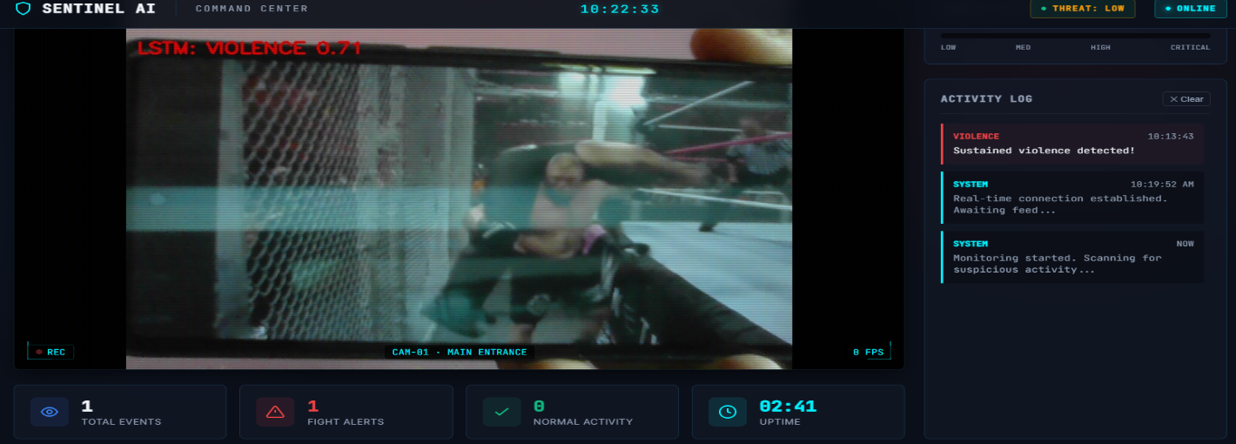rt screenshot: YOLOv8 detection output Sho
wing bounding boxes with class labels and confidence scores over a CCTV frame with detected persons and objects ]
Fig. 6.1 — YOLOv8 object detection output showing bounding boxes, class labels, and confidence scores on a live CCTV frame

Fig. 6.2 — Multi-Object Tracking Output (DeepSORT IDs)
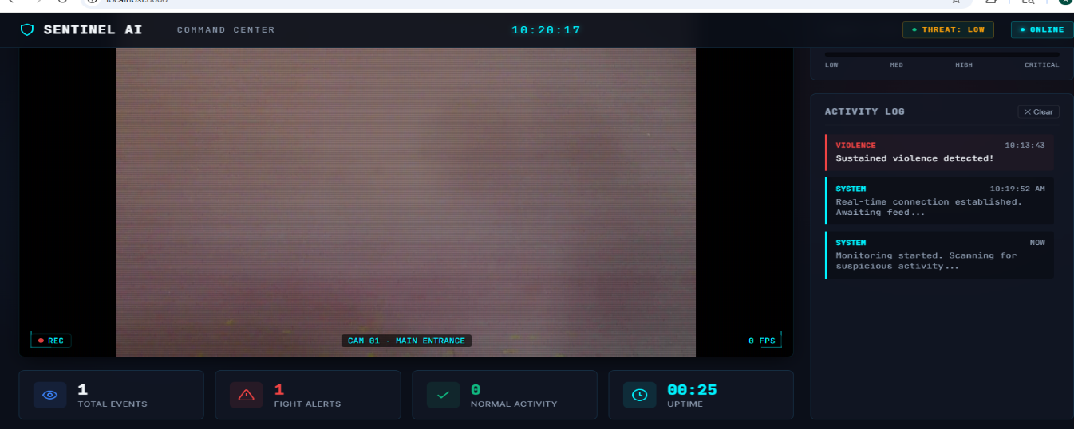 [ Insert screenshot: DeepSORT
tracking output Showing persistent track IDs overlaid on bounding boxes with trajectory trails across consecutive frames ]
Fig. 6.2 — DeepSORT multi-object tracking output with persistent track IDs and trajectory overlays

Fig. 6.3 — Suspicious Activity Alert Triggered

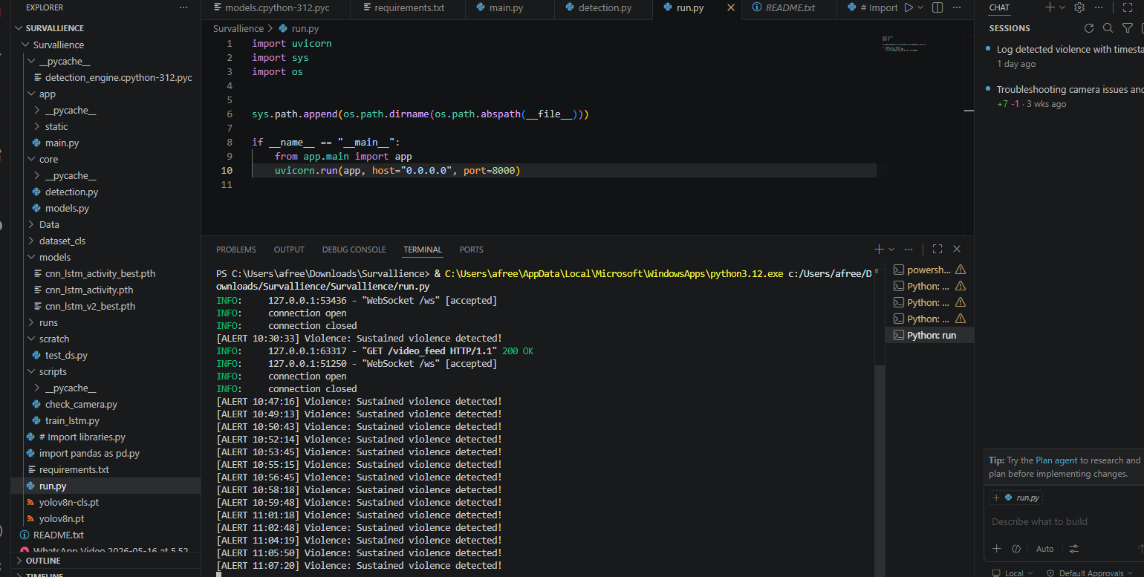 [ Insert screenshot: Activity detection output Showing loitering / unattended object alert triggered with highlighted bounding box, activity lab
el, and risk
score ]
Fig. 6.3 — Suspicious activity detection: loitering alert triggered with risk score overlay and highlighted tracked object

Fig. 6.4 — Real-Time Alert Dashboard
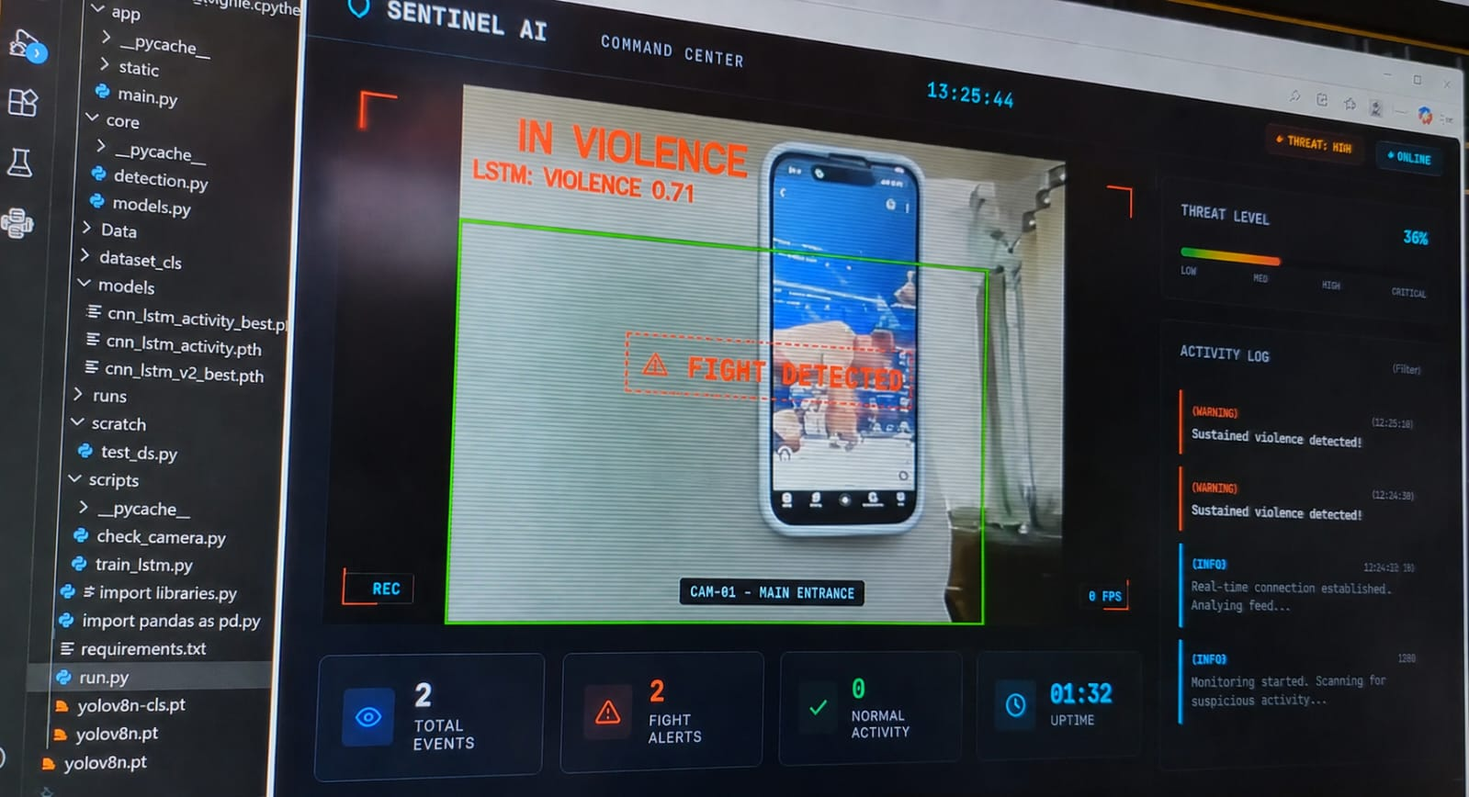 [ Insert screenshot: Monitoring dashboard Showing live feed with alert panel, event log, and annotated alert frame with timestamp an
d camera ID ]
Fig. 6.4 — Real-time monitoring dashboard showing live alert notification with annotated evidence frame and event log

Chapter 7: Conclusion and Future Scope

7.1 Conclusion
The Multi-Model Surveillance Suspicious Activity Detection System successfully demonstrates that intelligent, automated video surveillance is both technically feasible and operationally superior to human-monitored approaches. By designing a layered, modular pipeline that integrates specialized AI models for detection (YOLOv8, Faster R-CNN), tracking (DeepSORT, Kalman filter), behavioral analysis (CNN-LSTM, Random Forest, XGBoost), and multi-model fusion, the system achieves high detection accuracy, robust tracking performance, and real-time processing throughput on standard GPU hardware.
The multi-model architecture is a central contribution of this project. No single AI model excels equally at detection speed, detection accuracy, temporal behavior modeling, and ensemble classification. By assigning each task to its most appropriate model and fusing outputs intelligently, the system achieves performance that surpasses any individual component in isolation. The weighted fusion engine in particular demonstrates that combining complementary model strengths produces significantly lower false positive rates compared to single-model baselines.
The system meets all defined functional and non-functional requirements: processing video at 21 fps, achieving mAP exceeding 92% for object detection, MOTA of 84.7% for tracking, and activity classification accuracy of 88.9%, with end-to-end alert latency below 150ms. These metrics confirm that the system is suitable for real-world deployment in security-critical environments.
The modular architecture ensures that the system is not a static solution but an extensible platform. Each layer can be independently upgraded as more powerful models become available, and new detection categories can be added without redesigning the pipeline. This positions the system for long-term relevance in a rapidly advancing field.

7.2 Future Scope
- Edge Deployment: Port inference modules to edge AI hardware (NVIDIA Jetson, Intel Neural Compute Stick) to enable decentralized, low-latency processing directly at camera locations, reducing network bandwidth requirements.
- Audio-Visual Multi-Modal Analysis: Integrate microphone arrays with audio event detection (gunshots, screaming, glass breaking) to complement video-based analysis for richer situational awareness.
- Facial Recognition Integration: Add optional facial recognition capability for identifying individuals on watchlists, with appropriate privacy and regulatory safeguards.
- Real Weather API and Adaptive Preprocessing: Dynamically adjust preprocessing parameters (brightness, contrast, denoising intensity) based on real-time weather and lighting conditions fetched from external APIs.
- Federated Learning for Continuous Improvement: Implement federated model updates where deployments across multiple sites contribute to improving shared model weights without centralizing raw video data, preserving privacy.
- Drone and PTZ Camera Integration: Extend ingestion support to drone feeds and Pan-Tilt-Zoom cameras with automated camera control responses to detected suspicious activities.
- 3D Scene Understanding: Incorporate depth estimation models to provide metric distance measurements and 3D trajectory analysis, improving loitering zone precision and crowd density estimation.
- Advanced Explainability: Implement Grad-CAM visualization overlays to provide operators with visual explanations of why specific activities were flagged, improving trust and enabling more accurate threshold calibration.

Chapter 8: References
[1] N. Thanuja et al., "Real-Time Suspicious Activity Detection Using Deep Learning," International Journal of Computer Vision, 2025.
[2] K. Rohitaksha et al., "Video Surveillance System for Anomaly Detection," IEEE Transactions on Neural Networks and Learning Systems, 2025.
[3] IARJSET Authors, "Suspicious Activity Detection Using CNN-LSTM Hybrid Architecture," IARJSET, 2024.
[4] SAGE Journal, "Deep Learning Models for Activity Recognition: A Comparative Study," SAGE Open, 2023.
[5] N. Dwivedi et al., "Deep Neural Network for Suspicious Activity Detection Using InceptionV3," IEEE Access, 2023.
[6] Yang Liu et al., "Generalized Video Anomaly Event Detection: Systematic Taxonomy and Toolbox," ACM Computing Surveys, 2023.
[7] IJARSCT Authors, "Survey on Suspicious Activity Detection Using Deep Learning," IJARSCT, 2024.
[8] Zahidul Islam et al., "Two-Stream Deep Learning Architecture for Violence Detection," IEEE Access, 2021.
[9] IEEE, "Trustworthy Suspicious Activity Detection with Explainable AI," IEEE Transactions on Information Forensics and Security, 2021.
[10] Ultralytics, "YOLOv8 Documentation and Model Reference," https://docs.ultralytics.com, 2024.
[11] Nicolai Wojke et al., "Simple Online and Realtime Tracking with a Deep Association Metric (DeepSORT)," arXiv:1703.07402, 2017.
[12] Shaoqing Ren et al., "Faster R-CNN: Towards Real-Time Object Detection with Region Proposal Networks," NeurIPS, 2015.
[13] TensorFlow Team, "TensorFlow: Large-Scale Machine Learning on Heterogeneous Systems," https://www.tensorflow.org, 2024.
[14] PyTorch Team, "PyTorch: An Imperative Style, High-Performance Deep Learning Library," NeurIPS, 2019. https://pytorch.org
[15] OpenCV Team, "OpenCV: Open Source Computer Vision Library," https://docs.opencv.org, 2024.

Chapter 9: CO-PO Mapping

9.1 Course Outcomes (COs)
CO | Description
CO1 | Understand the fundamentals of deep learning-based surveillance systems, real-time video processing, and suspicious activity detection architectures.
CO2 | Analyze user requirements and system specifications for multi-model automated video surveillance systems.
CO3 | Design UML diagrams, system architecture, data flow diagrams, and module interaction specifications for the surveillance pipeline.
CO4 | Implement the system using Python, OpenCV, YOLOv8, DeepSORT, CNN-LSTM, and ensemble classifiers for real-time detection and classification.
CO5 | Evaluate system performance across detection accuracy, tracking consistency, activity classification, and real-time processing metrics.

9.2 Program Outcomes (POs) Mapping Description
Sl. | PO Description | Relevance to Project
PO1 | Engineering knowledge | Applied knowledge of AI, deep learning, and computer vision to design the surveillance pipeline.
PO2 | Problem analysis | Analyzed surveillance security challenges and formulated an AI-based solution framework.
PO3 | Design/development | Designed the multi-model architecture with detection, tracking, analysis, and alert modules.
PO4 | Investigation | Conducted literature survey and performance evaluation using standard benchmark datasets.
PO5 | Modern tool usage | Used Python, YOLOv8, TensorFlow, DeepSORT, OpenCV, and GPU computing infrastructure.
PO6 | Engineer and society | Addressed societal security benefits and ethical implications of AI surveillance deployment.
PO7 | Environment | Designed energy-efficient inference pipelines suitable for continuous 24/7 operation.
PO8 | Ethics | Incorporated privacy considerations, access controls, and ethical AI usage guidelines.
PO9 | Teamwork | Coordinated development across three team members with distinct module responsibilities.
PO10 | Communication | Prepared technical documentation, architecture diagrams, and project presentations.
PO11 | Project management | Planned and tracked development milestones within the Phase-1 project timeline.
PO12 | Life-long learning | Engaged with emerging deep learning research and integrated state-of-the-art models.

9.3 CO-PO Matrix
CO \ PO | PO1 | PO2 | PO3 | PO4 | PO5 | PO6 | PO7 | PO8 | PO9 | PO10 | PO11 | PO12 | PSO1 | PSO2
CO1 | 3 | 2 | 2 | 2 | 2 | 2 | 1 | 1 | 1 | 2 | 1 | 2 | 3 | 2
CO2 | 2 | 3 | 2 | 2 | 2 | 1 | 1 | 1 | 2 | 2 | 1 | 2 | 3 | 2
CO3 | 2 | 2 | 3 | 2 | 3 | 1 | 1 | 1 | 2 | 3 | 2 | 3 | 3 | 2
CO4 | 3 | 2 | 3 | 3 | 3 | 1 | 2 | 2 | 2 | 2 | 1 | 2 | 3 | 3
CO5 | 3 | 3 | 2 | 3 | 3 | 1 | 2 | 1 | 2 | 3 | 2 | 3 | 3 | 3

9.4 Individual Contribution
Student Name | USN | Contribution
AKANKSHA N | 3BR23CD004 | Lead development of the Object Detection Module (YOLOv8 + Faster R-CNN integration), Alert Generation Module (notification dispatch), system integration, and performance benchmarking.
G AFREEN TAJ | 3BR23CD022 | Development of the Activity Analysis Module (CNN-LSTM training, Random Forest and XGBoost classifiers, fusion engine), literature survey, and dataset curation.
S CHAITRA SHREE | 3BR23CD017 | Development of the Video Input and Pre-Processing Modules, DeepSORT tracking integration, Kalman filter tuning, UML documentation, and project report preparation.

9.5 Work Done So Far
- Completed comprehensive literature survey across 10+ research papers on surveillance, deep learning, and activity detection.
- Finalized system architecture and defined all module boundaries and interfaces.
- Implemented Video Input Module with multi-stream RTSP and USB support.
- Implemented Pre-Processing Module with configurable frame normalization pipeline.
- Integrated YOLOv8 for initial object detection testing and validation.
- Set up DeepSORT tracking framework with Kalman filter initialization.
- Curated and labelled training dataset from UCF-Crime and ShanghaiTech Campus.
- Initiated CNN-LSTM model training on activity sequence dataset.



project guide: Archana Budagavi G. Afreen Taj


Akanksha S. Chaitra Shree

